Gas Transportation Service

Request For Proposals

Public Service Company of Oklahoma

February 23, 2023

- INTRODUCTION

1.1 Purpose of Request for Proposals (“RFP”)
Public Service Company of Oklahoma (hereafter referred to as “PSO” or “the Company”), an Oklahoma Corporation Commission (“OCC” or “Commission”) regulated utility, through its affiliate, AEP Service Corporation (“AEPSC”), is seeking proposals from Bidders for firm gas transportation and related services to PSO power plants. The purpose of the Request for Proposals (“RFP”) process is to solicit, evaluate, and select proposals through a competitive bidding process which supports the Company’s objective to ensure reliable firm gas transportation at the lowest reasonable cost for its generating facilities. The competitive bidding process is designed to ensure that all Bidders are treated in an equitable and consistent manner. This RFP outlines PSO’s requirements and provides information and instructions to prospective Bidders participating in this solicitation.

1.2 Term
The three (3) year primary contract term for firm gas transportation and related services shall commence at 9:00 AM CPT on January 1, 2024 and shall end at 9:00 AM CPT on January 1, 2027. Furthermore, PSO shall have the right of first refusal of the maximum daily quantities (MDQ) identified in Table 2.2 for an additional three year term, provided that the parties reach agreement on applicable contract provisions at least two-hundred (200) days prior to the expiration of the primary contract term.

1.3 Instructions to Bidders
Bidders are required to follow all the instructions outlined in the RFP and Response Package contained within as Appendix A.

All firm transportation agreements will have specifically negotiated terms and conditions. The following is a non-exclusive list of sections that shall be addressed in the agreement.

- Description of firm transportation service
- Points of Receipt/Delivery
- Rates
- Term
- Scheduling, Allocation and Balancing
- Performance Security/Credit Assurances
- Arbitration
- Safety Compliance
- Miscellaneous (Notices, Joint Effort, Controlling Law, etc.)
- General Terms and Conditions (Measuring and Testing, Quality, Force Majeure, etc.)

Proposals must be submitted by email to: aepfuelsrfp@aep.com.
Those submitting proposals shall be responsible for the completeness and accuracy of all information contained in and used in preparation of its proposal(s) and for having supplied all necessary information.

AEPSC reserves the right to modify or withdraw this invitation, to reject any or all proposals, and to terminate any subsequent negotiations at any time. AEPSC also reserves the right to accept one or more proposal(s) for all, or a portion, of the firm gas transportation and related services offered within each proposal.

1.4 RFP Schedule
The anticipated schedule for the solicitation is presented below.
RFP Draft Issued January 17, 2023
Technical Conference February 1, 2023
Issuance of Final RFP February 23, 2023
Submission of Bids April 3, 2023, due 4:00 PM Central
Select Preferred Bidder(s) April 19, 2023, by 4:00 PM Central
Finalize Contract(s) May 25, 2023

1.5 Confidentiality
AEPSC will take reasonable precautions and use reasonable efforts to maintain the confidentiality of all proposals submitted. Bidders should clearly identify each page of information considered to be confidential or proprietary. AEPSC reserves the right to release any proposals to its agents or consultants for purposes of proposal evaluation.
Regardless of the confidentiality, all such information may be subject to review by the appropriate state jurisdiction, or any other governmental authority or judicial body with jurisdiction relating to these matters and may be subject to legal discovery. Under such circumstances, AEPSC will make reasonable efforts to protect the Bidder’s confidential information. If a formal Confidentiality Agreement is desired, AEPSC shall provide such Confidentiality Agreement, upon request.

1.6 Company Representative
All inquiries about the RFP should be directed to the Company’s Representative electronically. No interpretations, revisions, or other communications regarding this RFP are valid unless they are provided by the Company Representative or other authorized representative of the Company.

The Company will maintain complete documentation of all questions received electronically from Bidders and provide answers related to questions about the RFP to all Bidders to promote fairness and competition throughout the process. All questions received and answers provided from a conference on February 1, 2023 will be posted on the Company website.

The official Company Representative is:

Clint Stutler
AEP Service Corporation
Tel: 614.395.3562
cmstutler@aep.com
1 Riverside Plaza, 14th Floor
Columbus, OH 43215
- BACKGROUND TO THE RFP

2.1 Bidding Requirements
Firm service is available for bid for the PSO plants listed in Table 2.1 below.
Table 2.1
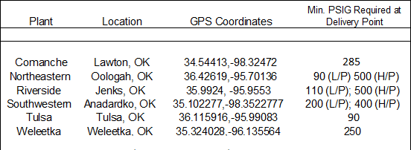

Hourly Swings
In determining the Company’s gas transportation requirements, an important factor is the ability for the pipeline to support hourly swings. Power plants can ramp up or down hourly during any given day in a dramatic fashion. Gas transportation capacity contracts with daily uniform flow provisions (1/24 of MDQ) cannot meet the total hourly swings required by PSO’s power plants if based on average daily non-coincident peak requirements alone.

Hourly swing needs relative to hourly maximum flows equivalent to 1/12 of MDQs are required to support plant operations. An approximate amount of total daily volume to be bid is specified in Table 2.2. (The Company uses the MMBtu nomenclature to describe the energy requirements of its power plants and will use such nomenclature subsequently in this RFP).

No Notice Service
PSO units can be called on during any hour of the day, thus PSO is requesting no notice service be offered as part of Bidder’s proposal.

Pipeline Connection Requirements
Any Bidder preparing a proposal based on the construction of a new pipeline into any of PSO’s generating facilities is responsible for conducting its own preliminary interconnection study for the project. All pipeline cost up to the header connection, if available, must be included in the Bidder’s price schedule. In the event there is either no header, or no header connection available, Bidder will submit a separate bid for construction costs associated with such new construction required. Such bid will provide a narrative description of the proposed construction, as well as a detailed listing of the material required and line item detail of the associated costs of construction. PSO will be responsible for all pipeline connection cost from the outlet flange of the meter to the existing pipes leading into the boilers. Company reserves the right, at its discretion, to negotiate with successful Bidders to reduce the cost of such interconnection for the benefit of its customers, if an alternative option appears viable. Company also reserves the right to perform the header or header connection construction itself or to contract with a third party to do so, if it deems such action to be in the best interest of its customers.

All new pipeline proposals must conform to the requirements shown below:
- PSO must be notified prior to and have the right to witness all meter inspections, tests, and calibrations. Meter telemetry information will be made available to PSO if requested.
- Heat content data (BTU/CF) must be available to PSO.
- The required pipeline pressure at the custody transfer point for each unit is listed in Table 2.1 above.

The Company encourages Bidders to make proposals which will not result in costly underutilization of the proposed service.

The table below indicates the volumes for which the bidders may offer firm transportation. PSO should have the ability to deliver natural gas, up to the MDQ, to any PSO plant to which Bidder’s facilities are connected.

Table 2.2
PSO Anticipated Requirements (Up to):
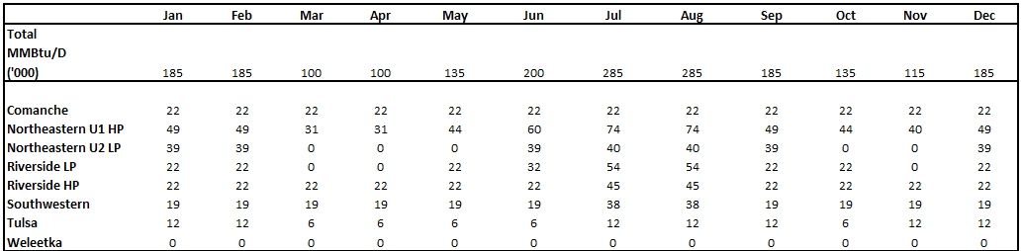

3. BID EVALUATION, AWARD AND CONTRACT FINALIZATION

3.1 Clarification Discussions
The Company will conduct further discussions with the Bidders to clarify and refine the terms of the proposals to ensure that both Bidders and Company have a thorough and consistent understanding of Company’s needs and Bidder’s proposed terms and services to meet those needs.

3.2 Evaluation and Award
During this phase of the process, the Company will conduct sensitivity analyses of key factors influencing cost including, but not limited to, variations in plant operations, price-related factors, and combinations of generating facility bid options. Upon completion of its evaluation, the Company will then advise each Bidder whether its proposal has been successful.

Proposals will be evaluated based upon the following factors:
- Delivered cost (dollars per million Btu); **
- Reliability of supply and transportation flexibility; **
- Previous experience with bidder or bidding company in past business with AEPSC;
- Terms and Conditions.

**Numbers (1) and (2) constitute the primary evaluation criteria and the combination of (1) and (2) that best suits the Company’s needs will be determinative of the award.

3.3 Contract Finalization
Finalization of required contracts with the selected Bidder(s) will begin immediately upon selection of the chosen bid(s).

MAP OF pso POWER PLANT SITES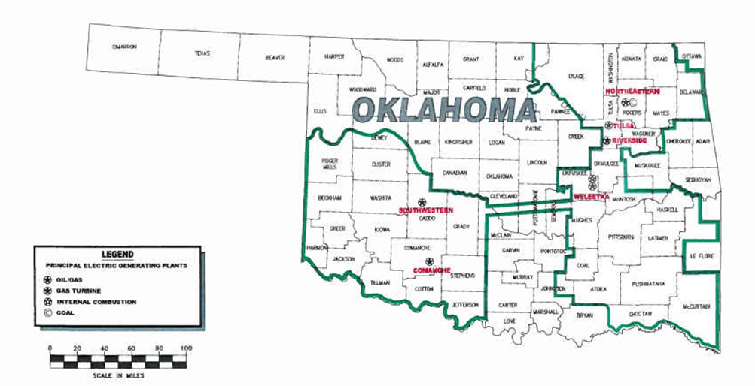

APPENDIX A
Response Package

1. BIDDER RESPONSE

1.1 Firm Service Pricing (Schedule 1-1)

Bidders are required to complete the Firm Service Pricing schedule contained in Schedule 1-1 of the Response Package. Bidders who wish to provide additional details about their pricing options should include such information within the response.

1.2 Firm Service Description (Schedule 1-2)

Bidders are required to complete the Firm Service Description schedule contained in Schedule 1-2 of the Response Package. If Bidders wish to provide additional details about their service options, the information can be included within the response.

Bidders should include any existing tariffs or terms and conditions relevant to the proposed service in the Response Package. The Company will conduct a detailed delivered cost analysis of each bid on a plant-by-plant basis, as well as assess the terms and conditions of various service options to allow for a complete and consistent system analysis.

1.3 Bidder Profile Form

Bidders are required to complete the Bidder Profile Form (Exhibit A).

Schedule 1-1

FIRM SERVICE PRICING

Delivered Price by Plant

Plant Options | Contract Start Date | Transportation
 |  | Reservation Rate | Other Surcharges (If Applicable) | Commodity Rate | Retainage / Lost and Unaccounted For Gas
Comanche | 1/1/2024
Northeastern HP | 1/1/2024
Northeastern LP | 1/1/2024
Riverside HP | 1/1/2024
Riverside LP | 1/1/2024
Southwestern HP | 1/1/2024
Southwestern LP | 1/1/2024
Tulsa | 1/1/2024
Weleetka | 1/1/2024

Schedule 1-2

Firm Service Description

Applicable PSO Plants (check all that apply)

Comanche | Northeastern HP | Northeastern LP | Riverside HP | Riverside LP | Southwestern HP | Southwestern LP | Tulsa | Weleetka

MDQ:

MHQ:

Term: 3 Years

Type of Service:

Daily Swing Allowance (min 1/12 without penalty):

Daily Nomination Flexibility:

Minimum Purchase Obligations:

Daily Imbalance, Scheduling Tolerance, and Description:

Monthly Imbalance, Scheduling Tolerance, and Description:

Overrun Charges and Conditions:

Receipt and Delivery Point Flexibility:

Other:

2. SUPPORTING INFORMATION

This section requests information related to Bidders’ proposals that are applicable to the non-price evaluation. Bidders are required to provide the following:

2.1 Acknowledgement that Bidders are willing to comply with all federal, state and local laws, ordinances, rules, and regulations applicable to the safe performance of the Work as specified in Exhibit B (AEP Safety and Health Requirements) when conducting work at the PSO work site. If Bidder cannot comply with the AEP Safety and Health Requirements attached as Exhibit B, Bidder must specify why compliance is not attainable and propose potential language for consideration.

2.2 Current tariffs and/or Statement of Operating Conditions, and terms and conditions for service.

